**JIRA SOFTWARE INSTRUCTIONS  
*for*   
*Engineering Reviews of Technical Publications***

Test!!!

TABLE OF CONTENTS

1. ACRONYMS & DEFINITIONS 2

2. EXAMPLES OF ISSUE TYPES 2

3. SWIMLANES (Column Names) 3

4. IMPORTANT STEPS IN JIRA 6

4.1. How to Log in to Jira 6

4.2. The Three Main Steps Performed in Jira 7

4.3. How to View Your Assignments 8

5. INSTRUCTIONS FOR ENGINEER 9

5.1. PDF Ready for Engineering Review 9

5.2. Engineering Review of PDF Complete 11

6. FILE NAMING CONVENTIONS 14

LIST OF FIGURES

Figure 1: Jira Workflow for Technical Publications (Flow of Projects, Epics, and Stories) 4

Figure 2: Jira Workflow for Technical Publications (Flow of Subtasks) 5

1. ACRONYMS & DEFINITIONS

|  |  |
| --- | --- |
| **Project** | Program/Contract Name in Jira |
| **Issue** | Any task created in Jira under a Project, such as an Epic (Delivery Milestone), Story (TO/Pub#), Sub-Task, etc. Each issue has a unique “issue key” assigned to it. The key consists of an abbreviated version of the Project Name and ends with a sequential number. |
| **Epic** | Delivery Milestone in Jira (e.g., IPR #1, 80% IPR, Verification, Final, etc.) |
| **Story** | Individual TO/Publication Numbers in Jira |
| **Sub-Tasks** | A task in Jira that is part of a Story (TO/Pub). Sub-Tasks will be named **‘**Illus**’**, **‘**Text**’,** or **‘**Combined**’**. |
| **Combined** | After theWriter inserts thecompleted illus files into the text files, the PDF created becomes Sub-Task ‘Combined’ (in Jira) since the text and illus are now combined together. |
| **Reporter** | The person that creates the Jira Issue |
| **Assignee** | The person assigned to work on the Jira Issue |
| **TL** | Task Lead |
| **TW** | Technical Writer |
| **ENG** | Engineer |
| **CXS** | Corrections |
| **WC** | Writer’s Copy |

1. EXAMPLES OF ISSUE TYPES

Each **Epic** refers to the different milestones for a contract. They are named according to what the customer refers to as a delivery (e.g., “IPR #1”, “40% IPR”, or “Verification”, etc.).

Each TO/Pub is referred to as a **Story**.

**Subtasks**:

‘Illus’ refers to the initial Illustration native files.

‘Text’ refers to the text portion of the Writer’s Copy without the illustrations being inserted yet (e.g., FrameMaker files).

‘Combined’ refers to the PDF of the text files after the illustrations have been inserted.

|  |  |
| --- | --- |
| **A-10 HRDS (OA06)** | *Project* |
| IPR #1 | *Epic* |
| TO 1A-10C-2-5 | *Story* |
| Illus | *Subtasks* |
| Text |
| Combined |
| TO 1A-10C-2-6 | *Story* |
| Illus | *Subtasks* |
| Text |
| Combined |
| IPR #2 | *Epic* |
| TO 1A-10C-2-5 | *Story* |
| Illus | *Subtasks* |
| Text |
| Combined |

|  |  |
| --- | --- |
| **T-6 CSR (N710)** | *Project* |
| 40% IPR | *Epic* |
| TO 1T-6ABD-2-1 | *Story* |
| Illus | *Subtasks* |
| Text |
| Combined |

1. SWIMLANES (Column Names)

There are 13 Swimlanes (Columns) that a subtask can reside in for the Technical Publication Department. The names of the swimlanes, and a short description of when a subtask would be moved into that swimlane, is defined below. The highlighted rows are the only two swimlanes that Engineers will use:

|  |  |
| --- | --- |
| **IN PROGRESS** | *When a TO/Pub or subtask is waiting to be assigned.* |
| **CREATE WC & ILLUS REQ** | *When the TW has been assigned to TO/Pub and begins creating the WC & Illus Request.* |
| **CREATE ILLUS FILES** | *When the Illus Request is ready for Illus to start creating the initial illus files.* |
| **CREATE TEXT FILES** | *When the Writer’s Copy is ready for the Writer to start creating the text files.* |
| **COMBINE & TW REVIEW \*\*** | *When Illus is done with illus files and needs to notify the Writer to combine & review.*  *It is also when Illus finishes TW’s CXS and needs to notify the Writer to combine & review.* |
| **TW’S CXS** | *When the Writer needs to notify the Illustrator that Corrections are ready for them.* |
| **ENGINEERING REVIEW** | *When the Writer needs to notify the Engineer that the PDF is ready for engineer review.* |
| **TW REVIEWS ENG’S REDLINES** | *When the Engineer completes their redlines and needs to notify TW that it’s ready for review.* |
| **ENG’S CXS** | *When the Writer needs to notify the Illustrator to correct the Engineer’s markups.* |
| **RECOMBINE & TW REVIEW** | *When Illus finishes Eng’s Corrections and needs to notify Writer to fix text & recombine.*  *It is also when Illus finishes QA’s Corrections and needs to notify Writer to fix text & recombine.* |
| **QA/LW REVIEW** | *When the Writer needs to notify QA (or LW) that the Combined File is ready to proof.* |
| **QA/LW’S CXS** | *When QA needs to notify the Illustrator (illus) and/or Writer (text) of needed Corrections.* |
| **DONE** | *When QA/LW Approves the Combined Copy.* |

**\*\***This is the point when Writer renames the ‘Text’ Subtask to ‘Combined’ and moves the ‘Illus’ Subtask to the **DONE** swimlane.



Figure : Jira Workflow for Technical Publications (Flow of Projects, Epics, and Stories)



Figure : Jira Workflow for Technical Publications (Flow of Subtasks)

1. IMPORTANT STEPS IN JIRA
   1. How to Log in to Jira
2. Navigate to this site: [**https://tticket.scires.com/login.jsp**](https://tticket.scires.com/login.jsp)
3. Enter your **SRC Username** and **Password** (do not type “scires” before your username).
4. Select the checkbox “**Remember my login on this computer**”.
5. Click **Log In**.
6. **Tip**: Bookmark this site to your toolbar for quick access.
7. After logging in, the first step is to view the project you are working by clicking on the **Projects** button on the top menu bar, and then selecting the project name from the drop-down menu. If the Project Name is not visible, select “View All Projects” to search for it.

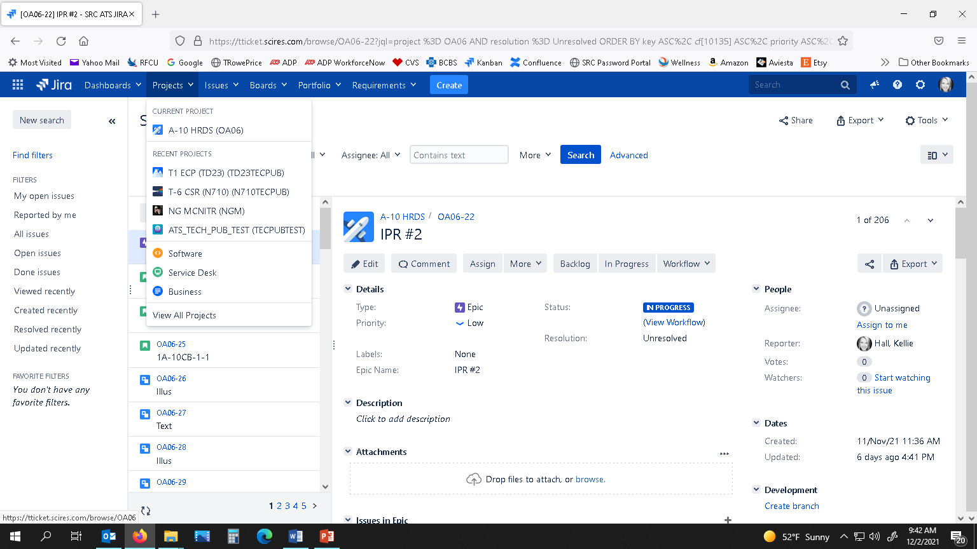

1. Next, in the left-hand pane, click on **Kanban board**. This will be the main working area.

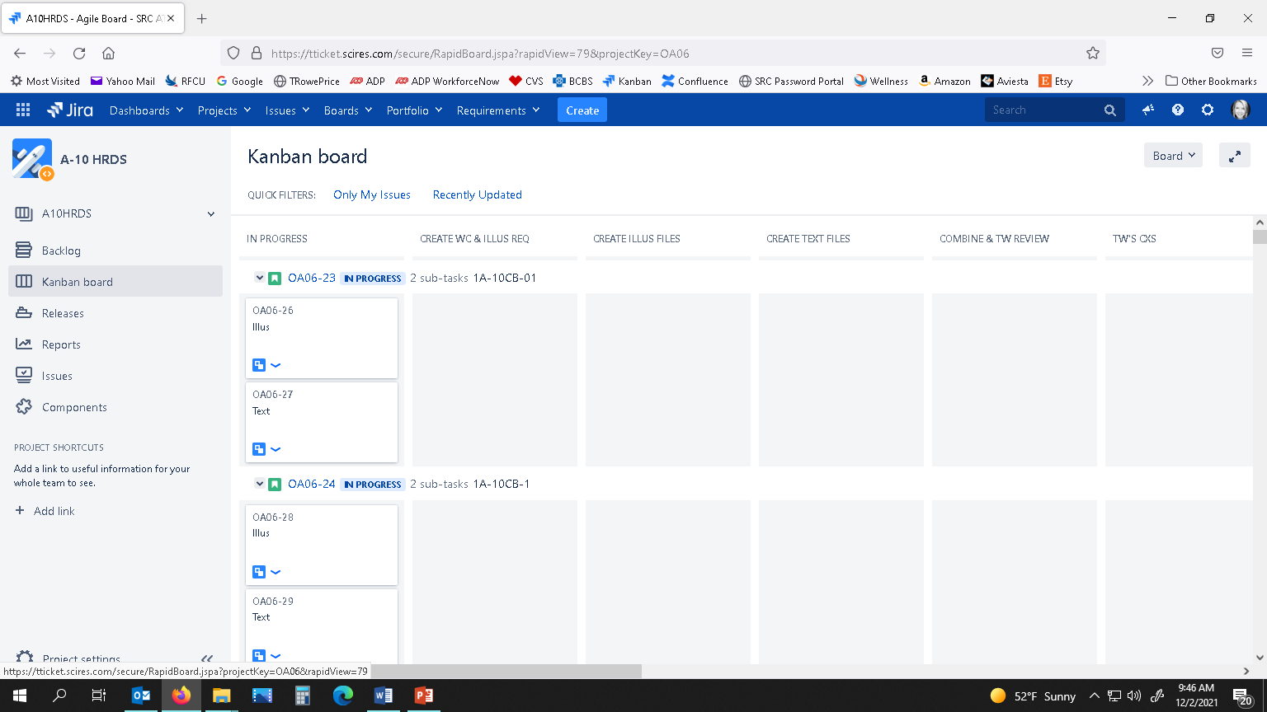

* 1. The Three Main Steps Performed in Jira

These are the three main actions that have to be performed in Jira **after** you have finished performing an Engineering Review and have saved the PDF with your redlines on the P drive in the “Tech Pubs - Engineering Review” folder for that specific contract (see Naming Conventions, Section 6). Instructions for performing these steps can be found in Section 5. **It is important to perform these steps each time you complete a review and in the correct order as shown below.**

1. **Click and drag the “Combined” Sub-Task (card) found under the Tech Pub#’s row from the “ENGINEERING REVIEW” swimlane to the “TW REVIEWS ENG’S REDLINES” swimlane.**
2. **Add an Entry to the Description section of the Subtask.** *(To keep a log of the work performed.)*
3. **Change the Assignee to the Tech Writer.** *(This will trigger an email notifying TW that they have an assignment.)*
   1. How to View Your Assignments

There are several ways to view your assigned issues:

1. Select the correct Project from the Projects drop-down menu. Click Kanban board in the left pane. Next to “QUICK FILTERS:” click the Only My Issues filter toggle link. This will show all issues assigned to you on the Kanban board.

**-OR-**

1. Click the link you receive in your email when an issue has been assigned to you, and it will lead you straight to that issue’s details.

**-OR-**

1. On the top ribbon in Jira, click the Issues drop-down arrow and select My Open Issues. Your assigned issues will be listed on the left. Click on the individual issue for more details.

**-OR-**

1. Use the Search tool at top right of the Jira screen to search for any TO/Pub# within that project or to search for a particular issue key number (e.g., OA06-27).
2. INSTRUCTIONS FOR ENGINEER
   1. PDF Ready for Engineering Review
3. In Jira, view the appropriate project by clicking the Projects drop down arrow on top menu bar and select the project name.

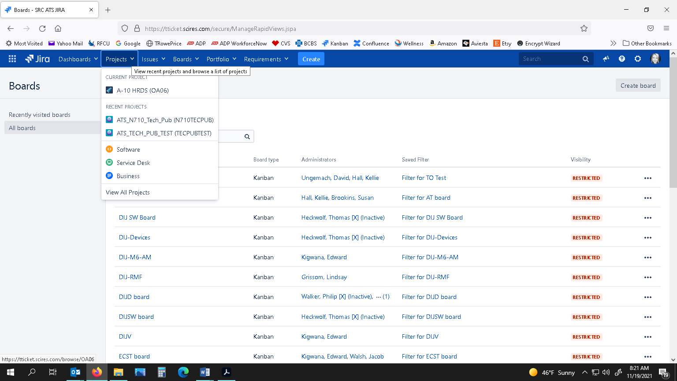

1. If not already visible, on the left-hand pane, click the Kanban board link.

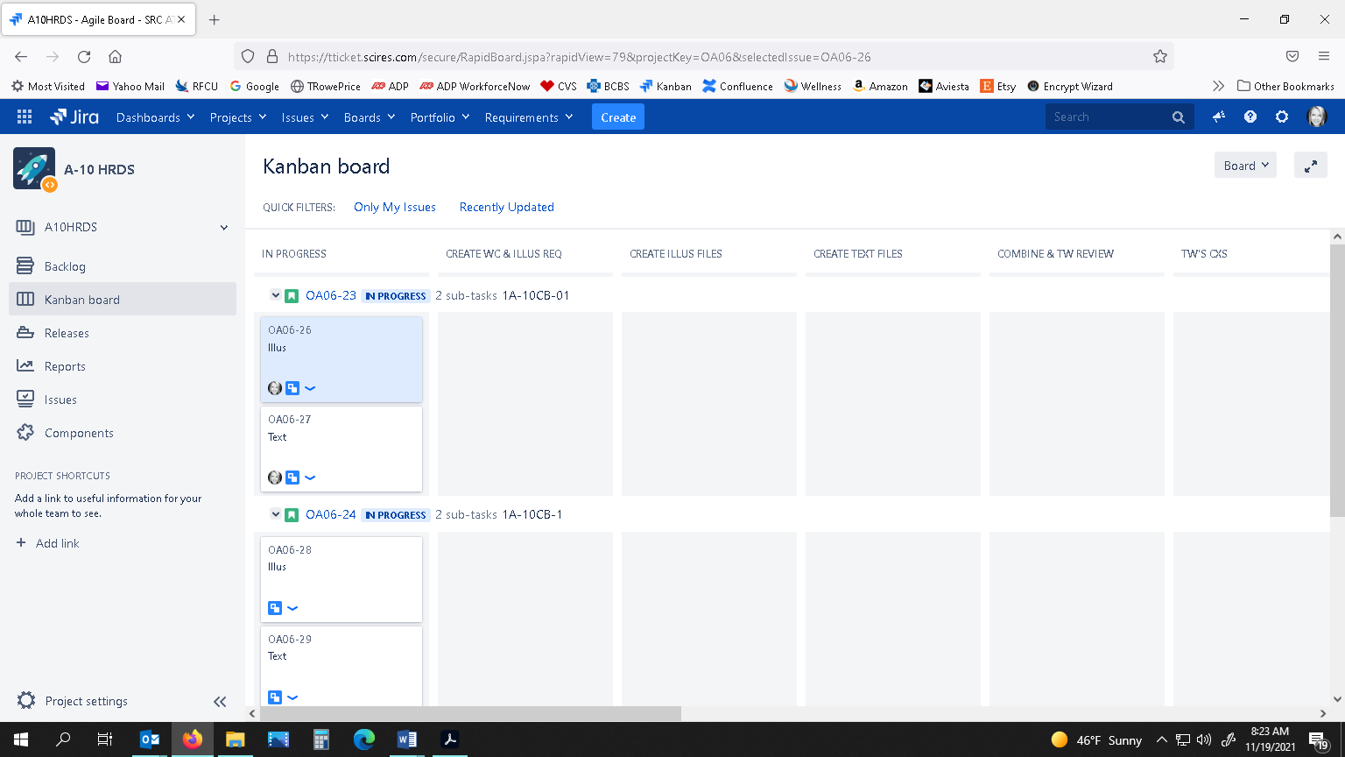

1. Click the filter “Only My Issues” toggle link at the top of the board.



1. Scroll to the right of the Kanban board using bottom scroll bar until the ENGINEERING REVIEW column is visible.

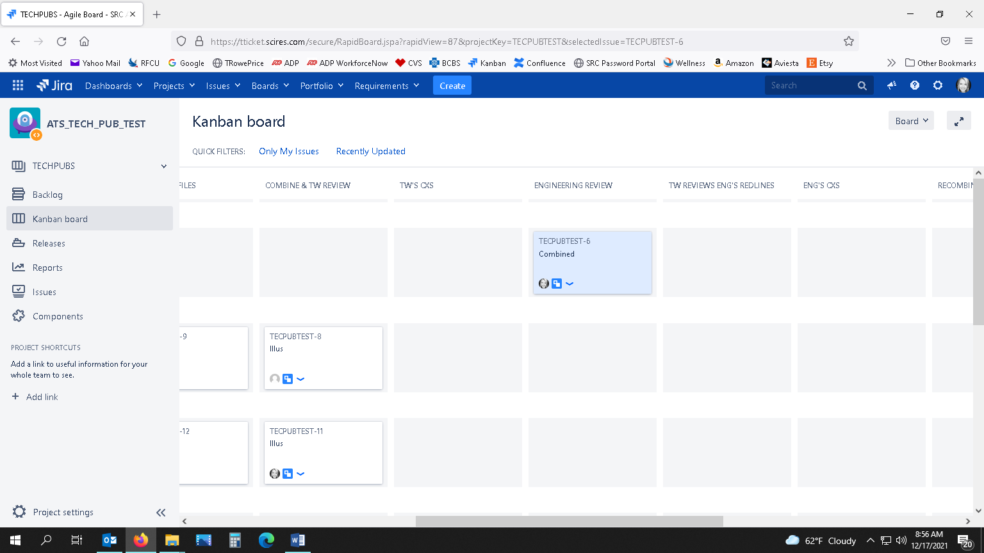

1. Everything assigned to you for an Engineering Review will be visible here.
2. Click on the ‘Combined’ Subtask under the Tech Pub’s row that needs an engineering review.
3. A Details panel will appear on the right-hand side of the screen. Scroll to the “Description” area.

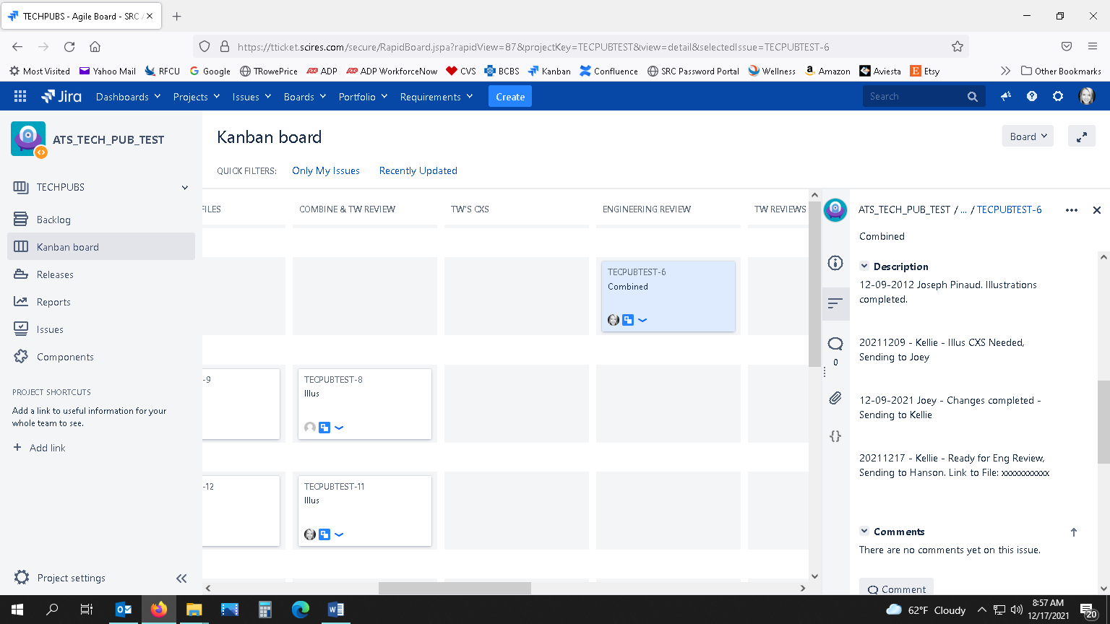

1. Here will be multiple entries on what work has been performed on this issue so far. Look at the last entry. It should read “Date – Name – Ready for Engineering Review, Sending to (Name)” and will be followed by a link to where the PDF is that is ready for you to review and redline. Copy and paste this link into your Windows Explorer.
2. Perform your review. You can use the markup tools in Acrobat to redline the PDF. (Instructions will be sent on how to use these markup tools if you are not familiar with them.)

* 1. Engineering Review of PDF Complete

1. When you have completed your engineering review, log into Jira, click the Projects drop-down arrow on the top menu bar, and select the appropriate project.
2. If not already selected, click the Kanban board link in the left pane.
3. Click the filter “Only My Issues” toggle link at the top of the board.
4. Find the Tech Pub’s row that you have finished reviewing the PDF for. The Tech Pub Numbers are listed as rows on the Kanban board following the issue key as seen below:

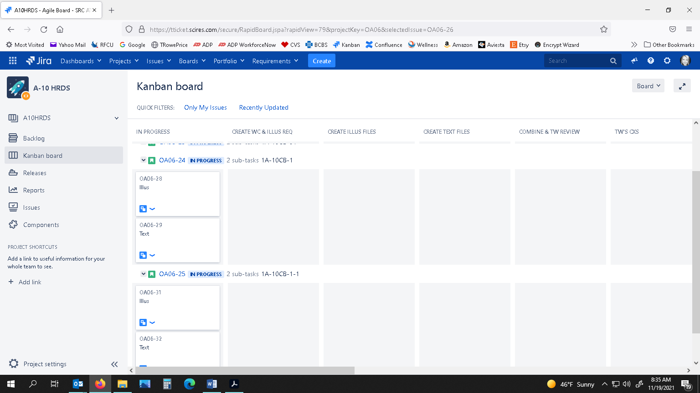

**Tech Pub#’s Row**

1. Scroll to the right on the Kanban board using bottom scroll bar until the ENGINEERING REVIEW swimlane is visible.
2. Click and drag the “Combined” card (under the Tech Pub’s row for which you performed a review) to the next swimlane titled “TW REVIEWS ENG’S REDLINES”.

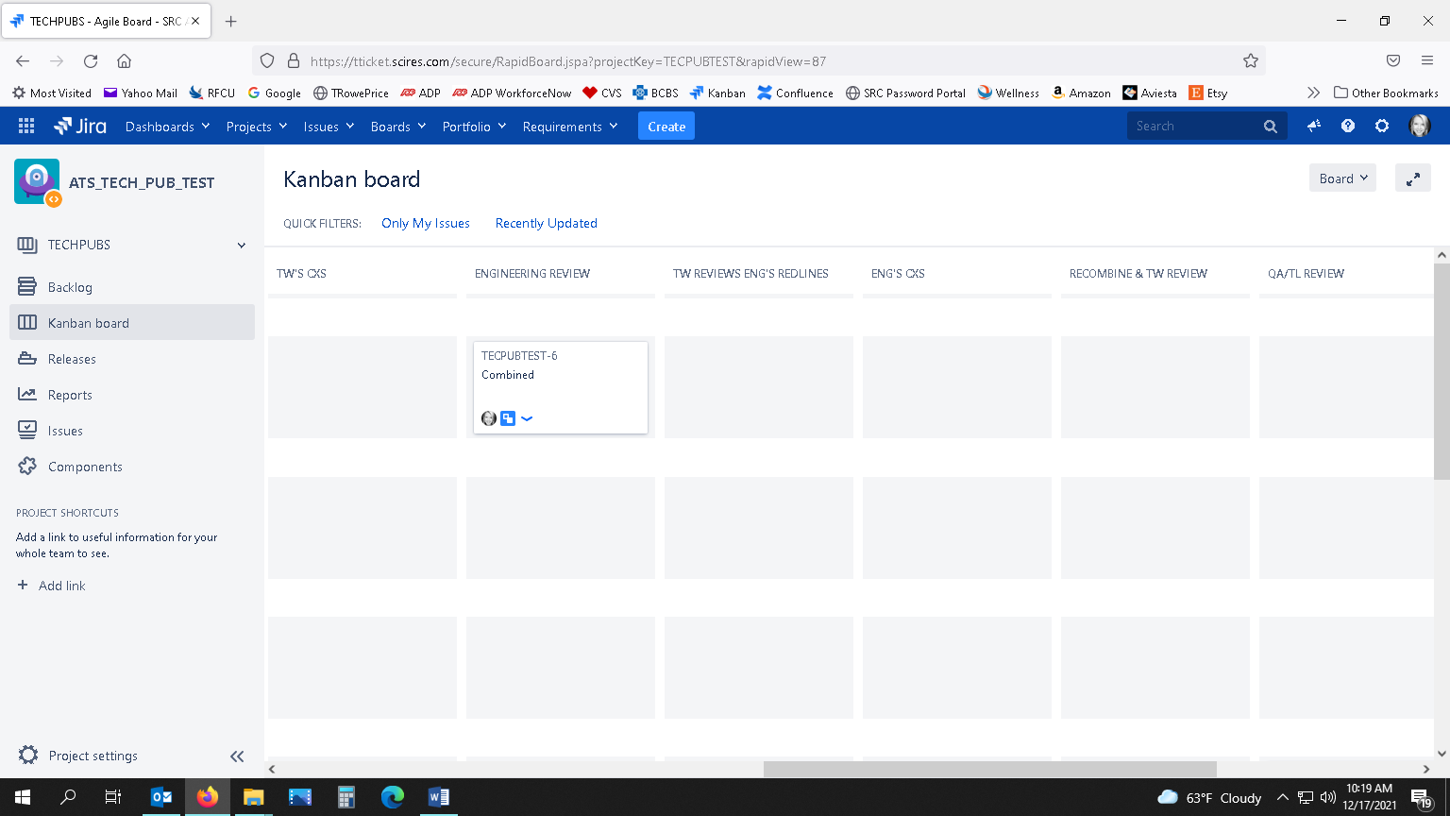

1. While the “Combined” card is still selected, look at the Details pane on the right-hand side of the screen. If it is not visible, click on the “Combined” card again.
2. Scroll to the Description area, click at the end of the last entry, enter a hard return, then type “Date – Your Name – Engineering Review Complete, Sending to (Writer’s Name)”. (You can look at previous entries to see who the Writer is.)
3. Next, scroll to the People section and change the Assignee to the Tech Writer, and then click the checkmark box.

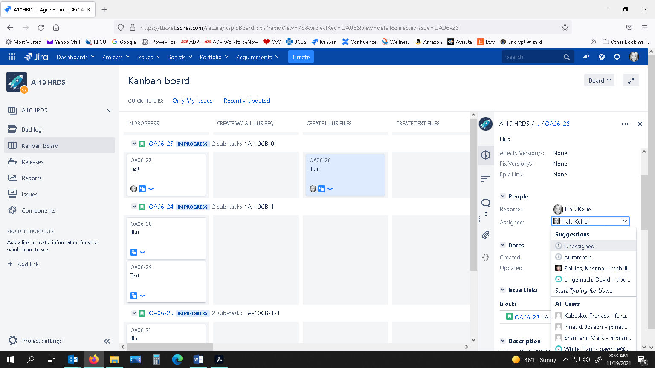 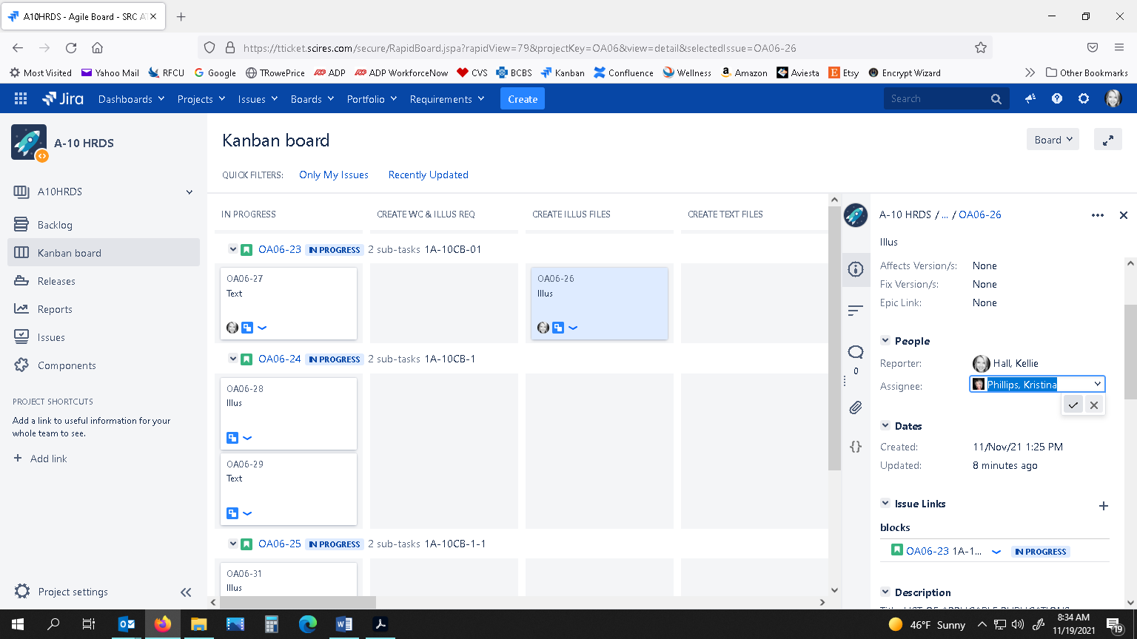

1. The Writer will now receive an email notifying them they have an assignment ready for them.
2. FILE NAMING CONVENTIONS

*File Naming Convention:* XX_TO/PUB# - Description of File - Date.pdf

*File Naming Example:* **01_1A-10C-2-15JG2-2-1A - Ready for ENG Review - 20210714.pdf**

Incremental Number TO Number Description/Process Completed Date



* We should set up a “TECH PUBS - ENG REVIEW” folder on the P drive for each project. The P drive is something we all have access to, but the Engineers don’t have access to our WIP folders…plus, it would be confusing for them navigating through our folders.
* All PDFs ready for an Engineering Review are located on the P drive under the Contract’s Project_Team folder. The folder will be named “Tech Pubs – Engineering Reviews”. Only redline the PDFs in that folder that have been assigned to you in Jira.

|  |  |
| --- | --- |
| **WHEN PDF IS READY FOR ENG REVIEW** When naming the PDF for Engineer Review, the file should be named: | |
| *Example:* | **01**_1A-10C-2-15JG-2-2 - **Ready for ENG Review** - 20210714.pdf |
| **WHEN ENGINEER’S REDLINED COPY OF PDF IS COMPLETE** When Engineer has finished their review, the file should be named: | |
| *Example:* | **02**_1A-10C-2-15JG-2-2 - **ENG Review Complete** - 20210715.pdf |